|  |
| --- |
| *Technical Design Specification* |

|  |  |  |  |
| --- | --- | --- | --- |
|  | Name | Role | Date |
| Author | Raju Lakide | ABAP Technical Consultant | 24-12-2024 |
| Reviewer |  |  |  |

Contents

Index of Changes 3

1. Purpose and objective 4

2. Type of Specification 4

3. Document References 4

4. Technical Design 4

4.1. Technical Design Summary 4

4.2. Data Dictionary 4

4.3. Transaction 4

4.4. Classes 5

4.5. BadI 5

4.6. Other Kind of development 6

4.7. Error Condition Handling 6

4.8. Additional Information 6

Index of Changes

|  |  |  |  |
| --- | --- | --- | --- |
| Date | Version | Description of Change | Author |
| 24-Dec-2024 | 2.0 | Getting error while uploading the sales extension template | Raju L |
|  |  |  |  |
|  |  |  |  |

# Purpose and objective

# This document describes the future contract & validation .

# Type of Specification

|  |  |
| --- | --- |
| Program type: | Report (read only)  Update function    Utility  Enhancement (user-exit, BADI, function module)  Modification  SAP GUI Dynpro  Web Dynpro  Interface  Inbound  Outbound  BW extractor |

# Document References

|  |  |  |  |
| --- | --- | --- | --- |
| Ref. | Document Name | Version | Remarks |
|  |  |  |  |

# Technical Design

Technical Design Summary

**Decommission event.**

While uploading sales extension template getting error as entry **JOSG 4 does not exit**

* In existing logic, passing the values as incorrect(I.e., Passing the same Tax classification for customer for all)

**Logic:**

* Update the logic for individual tax classification numbers

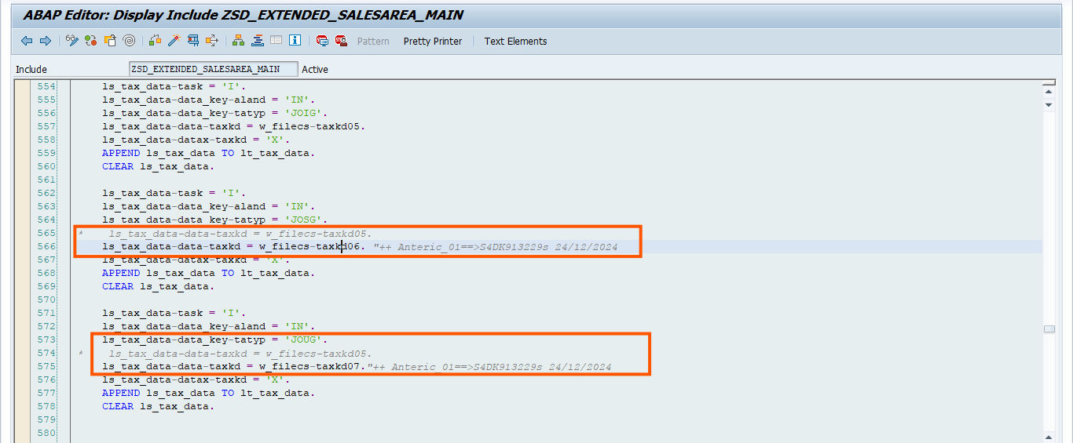

To display Output

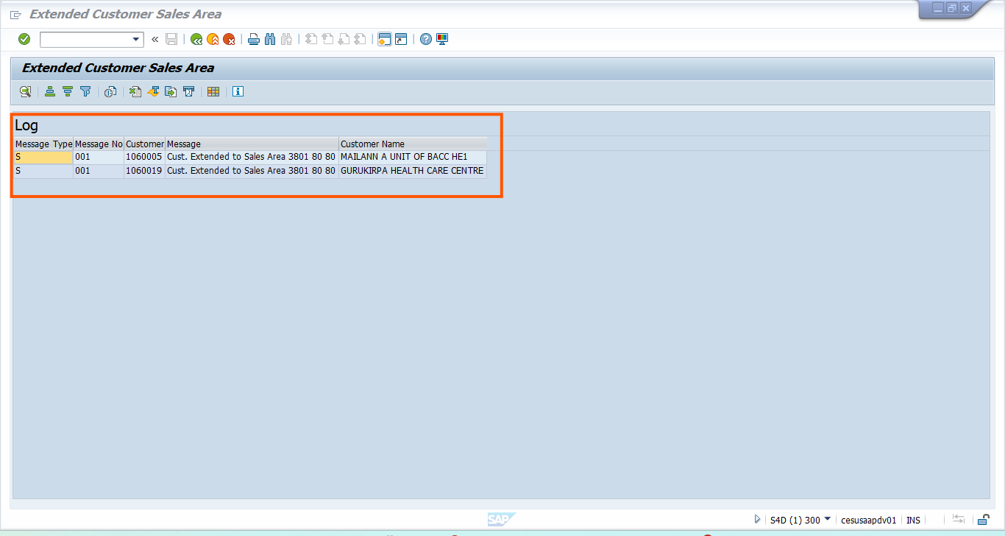

**T-Code:**

**ZSD_SALEEXT**

Data Dictionary

n/a

Classes

BadI

Other Kind of development

n/a

Error Condition Handling

n/a

Additional Information

n/a